SMART INDIA HACKATHON 2026

LUME
Land Acquisition Early-Warning, Foresight & Intervention Intelligence
SIH26017 • Ministry of Rural Development • Ultimate Final PRD • Version 6.0
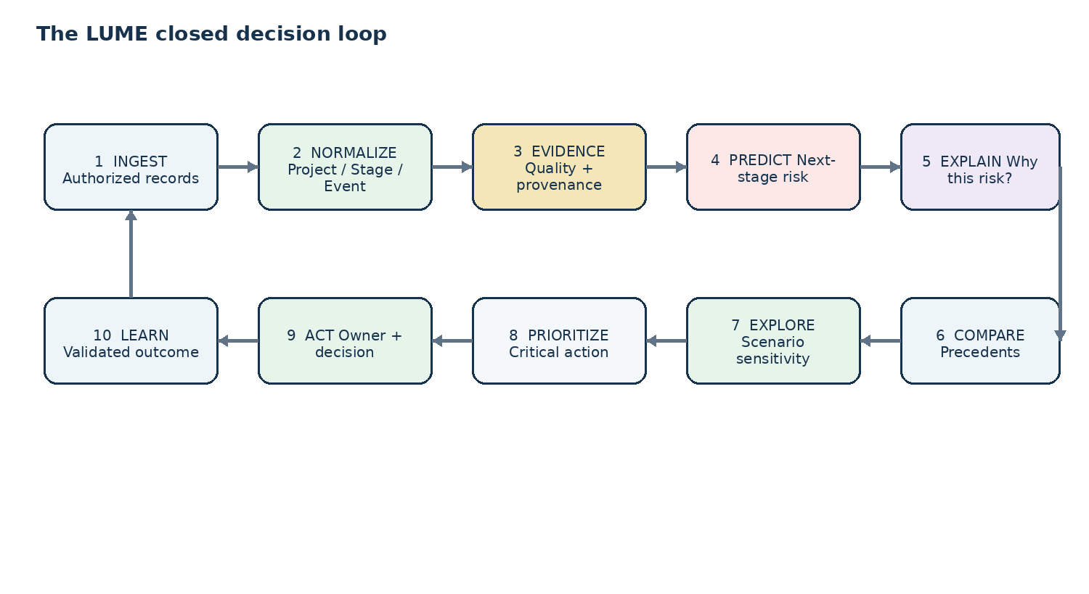
THE PRODUCT IN ONE SENTENCE
LUME turns existing land-acquisition information into foresight: it predicts the next stage most likely to slip, proves the evidence behind that prediction, finds comparable precedent, explores supported interventions, and prioritizes what should be investigated first.

North star: make emerging acquisition bottlenecks visible early enough for a human decision-maker to act.

1. Executive Product Vision
LUME is a government decision-intelligence platform for land acquisition. Existing systems remain authoritative; LUME adds a disciplined intelligence layer that converts project records into point-in-time predictions, evidence-backed explanations, historical precedent, controlled scenario analysis, and accountable follow-up.
The product is deliberately centered on one decision: which active acquisition case deserves attention now, why, what historical evidence supports that assessment, and what should be investigated next.


1.1 Product contract
Every LUME prediction contains | Meaning
Stage | The process stage to which the risk belongs.
Horizon | The period over which the next milestone is evaluated.
Probability | Calibrated model output, not an unexplained score.
Evidence health | GREEN / AMBER / RED support state.
Coverage | Whether the current case is represented within model support.
Explanation | Top drivers mapped to observable evidence.
Version | Model, feature snapshot and data snapshot identifiers.
Action context | The related critical dependency or investigation priority.

1.2 Product principles
- Intelligence over duplication: use existing records as inputs and add decision value.
- Evidence before confidence: every material prediction carries provenance and support context.
- Stage-specific reasoning: never collapse all acquisition behavior into one generic delay score.
- Point-in-time integrity: the model only uses information that was available at the prediction time.
- Human-controlled decisions: LUME prioritizes investigation; authorized officials remain decision owners.
- Institutional memory: validated outcomes become reusable precedent and training signal.
- Pilot-first architecture: the SIH build is locally demonstrable and structurally ready for secure integration.

2. Problem, Opportunity & Strategic Fit

2.1 The problem
Land acquisition is a dependency-heavy process spanning notifications, verification, objections, valuation/compensation, clearances, legal matters, rehabilitation and resettlement, possession and related administrative steps. The practical management challenge is not simply knowing a project’s current status; it is recognizing the next transition most likely to miss its expected window while there is still time to intervene.

2.2 Why now
The official SIH26017 listing specifically asks for AI/ML delay prediction, project-wise risk assessment, key delay drivers, explainable AI, dashboards, GIS, alerts, comparative analytics, recommendations and continuous learning. SIH also notes that a dataset is provided and explicitly encourages teams to scope the advanced problem tightly.
SIH26017 problem statement

India already has substantial digital land and acquisition infrastructure. DILRMP publishes state/UT land-record and map digitization indicators; its public dashboard demonstrates that coverage and maturity vary materially across places, making a data-quality-aware intelligence layer especially important.
DILRMP MIS and map/ULPIN dashboard

BhoomiRashi, operated by the Ministry of Road Transport and Highways, already provides a digital National Highway land-acquisition workflow. The Department of Land Resources maintains LACRRIS information, while NJDG provides judicial data and analytics. These are not reasons to build another portal; they are reasons for LUME to become the intelligence layer above existing records.
BhoomiRashi Department of Land Resources / LARR NJDG

2.3 Opportunity
OPPORTUNITY
Connect authorized process signals, evidence and historical outcomes into a stage-aware intelligence loop that helps decision-makers intervene earlier and more selectively.

2.4 Strategic position
LUME IS NOT ANOTHER LAND PORTAL
Existing systems remain the source of truth. LUME is the predictive and decision layer that interprets process signals before the next bottleneck becomes critical.

3. Existing Ecosystem & Complementarity
Ecosystem / system | Existing value | LUME role
DILRMP | Land-record modernization, cadastral/map linkage, registration and land information. | Consume authorized land-information signals; add risk and decision intelligence.
BhoomiRashi | Digital National Highway land-acquisition workflow and reporting. | Consume workflow/milestone signals; provide predictive triage above them.
LACRRIS / DoLR information | Land acquisition compensation, rehabilitation and resettlement information/reporting. | Use authorized historical/project signals for prediction and precedent.
NJDG / eCourts | Judicial data and analytics. | Use permitted case metadata as one risk-signal family.
PM GatiShakti ecosystem | Integrated, geospatial infrastructure-planning direction. | Prepare a geospatial/API boundary for future approved integration.
Departmental/manual workflows | Officer judgment, spreadsheets, reviews and escalation. | Convert repeated patterns into explainable institutional memory without replacing human judgment.

3.1 Evidence from the current public landscape
The current DILRMP public dashboard reports large national land-record digitization progress but also shows partial map/ULPIN coverage across the country; this reinforces the requirement that LUME must understand data quality and coverage instead of treating every record as equally complete.
DILRMP current public dashboard

A December 2025 Parliamentary Standing Committee review also highlighted implementation and community-process concerns under the LARR framework. LUME therefore treats stakeholder/process context as a governed signal family, not as a simplistic “social sentiment” score.
PRS summary of Standing Committee report

3.2 Design implication
The product must be designed around heterogeneous data maturity. LUME treats data health as part of the decision itself: the same prediction contract can produce a full prediction, a constrained result, or a baseline-only result depending on what is actually supported by the evidence and training coverage.

4. Users, Roles & Jobs-to-be-Done
User / role | Primary question | LUME answer
District / acquisition officer | What deserves attention today? | Ranked intervention queue with stage risk, evidence and precedents.
Senior departmental officer | Which projects threaten portfolio execution? | Criticality-aware portfolio ranking, trends, review packets.
Project / PMU team | Where can acquisition block the wider project? | Milestone risk and critical-dependency view.
Legal / grievance team | Where is dispute-related process risk emerging? | Authorized case signals + stage context + precedents.
Data / IT administrator | Can the intelligence be trusted and governed? | Data quality, connector health, model registry, audit.
Program / policy analyst | Where are systematic bottlenecks repeating? | Comparative analytics across stage, district, department and route.
Authorized citizen surface — future | What is the official status of the acquisition? | Read-only, officially published milestone/status information.

4.1 Human decision boundary
LUME SUPPORTS HUMAN DECISION-MAKING
LUME surfaces risk, evidence, precedent and suggested investigation priorities. Authorized officials retain responsibility for legal, compensation, administrative and operational decisions.

5. End-to-End Product Experience
The ideal user journey is a single continuous flow rather than a collection of disconnected modules:
See → Understand → Explain → Compare → Explore → Prioritize → Act → Learn
Moment | What the user experiences
See | Portfolio immediately surfaces the projects and stages that merit attention.
Understand | Project room shows current state, stage age and critical dependencies.
Explain | Risk explanation traces major drivers to source evidence.
Compare | Comparable historical acquisitions reveal how similar situations behaved.
Explore | Scenario Lab tests supported assumptions and shows modelled sensitivity.
Prioritize | Intervention engine ranks candidate follow-ups transparently.
Act | Officer assigns/records an action and due date.
Learn | Validated outcomes strengthen future benchmarks, precedents and models.

6. Complete Product Feature Set
ID | Capability | Product requirement | Priority
F01 | Portfolio Command Center | All active projects; next-stage risk; evidence health; model coverage; stage age; criticality; blockers; alerts; filters. | P0
F02 | Project Intelligence Room | Canonical project page with timeline, stage, dependencies, evidence, risk, precedents, scenarios and actions. | P0
F03 | Stage-Risk Engine | Predict next supported milestone miss probability for a defined horizon. | P0
F04 | Evidence & Explanation | Human-readable drivers linked to source events, freshness, reliability and model version. | P0
F05 | Evidence Health | GREEN/AMBER/RED state controlling prediction presentation. | P0
F06 | Critical Path View | Connect dependency age, downstream reach, ownership and risk interaction. | P0
F07 | Precedent Intelligence | Similarity retrieval with reasons, outcomes, interventions, evidence quality and spatial context. | P0
F08 | Scenario Lab | Supported one-variable or controlled scenario sensitivity. | P0
F09 | Intervention Priority Engine | Transparent ranking across risk movement, urgency, criticality and actionability. | P0
F10 | GIS Intelligence | Risk map, precedent layer, synchronized filters, project drill-down. | P0
F11 | Alerts & Change Feed | Risk crossing, milestone-window approach, inactivity, evidence changes. | P0
F12 | Review Packet | One-page project/portfolio review brief. | P0
F13 | Decision Log | Records acknowledgement, scenario, action and outcome events. | P0
F14 | RBAC | Role-specific permissions and data visibility. | P0
F15 | Model Registry | Training range, model, feature specification, calibration, metrics and promotion state. | P0
F16 | Integration API | Projects, predictions, evidence, precedents, scenarios, actions, alerts, audit, health. | P0
F17 | Learning Loop | Validated outcomes become labels, benchmark updates and precedent records. | P0
F18 | Comparative Analytics | Stage/district/state/department/route trends and benchmarks. | P1
F19 | LUME Citizen | Approved read-only milestone/status surface. | P2
F20 | Federated Precedent Layer | Cross-program / cross-agency memory with governed sharing. | P1/P2
F21 | Document Intelligence | Future extraction of structured events from authorized notices/orders. | P2
F22 | Infrastructure Readiness | Future extension to right-of-way, utilities, clearances and related dependencies. | P2

7. Canonical Data & Knowledge Model
Entity | Purpose | Key fields
Project | Acquisition case/program object | project_id, authority, department, purpose, location, criticality, process_route
Stage | Lifecycle state at time t | stage_id, type, expected_window, actual_start, actual_end, status
Event | Observed process activity | event_id, stage_id, type, effective_at, recorded_at, source_ref
Dependency | Condition affecting downstream progress | dependency_id, type, status, owner, due_date, downstream_reach
Evidence | Source-backed support for facts and drivers | source_id, source_type, effective_at, retrieved_at, reliability, reference
Prediction | Point-in-time model output | prediction_id, stage_id, probability, horizon, model_version, coverage, evidence_health
Precedent | Comparable historical case | precedent_id, project_ref, similarity, reasons, outcome, evidence_quality
Scenario | Controlled model alternative | scenario_id, baseline, changes, support_status, output, assumptions
Action | Human-owned follow-up | action_id, category, priority, owner, due_date, status, outcome
AuditEvent | Governance trail | actor, timestamp, object, operation, version

7.1 Temporal integrity
Every feature used by the predictive pipeline must be reconstructable as-of the prediction timestamp. LUME stores both effective time and ingestion/retrieval time so the pipeline can distinguish when an event happened from when the system learned about it.

7.2 Configurable process taxonomy
LUME does not hard-code a single universal sequence for every acquisition route. A route-specific taxonomy maps source stages into a common analytical vocabulary while retaining the route-specific sequence. This supports comparability without falsely assuming all acquisition cases follow identical legal or administrative steps.

8. Data Ingestion, Quality & Evidence Architecture
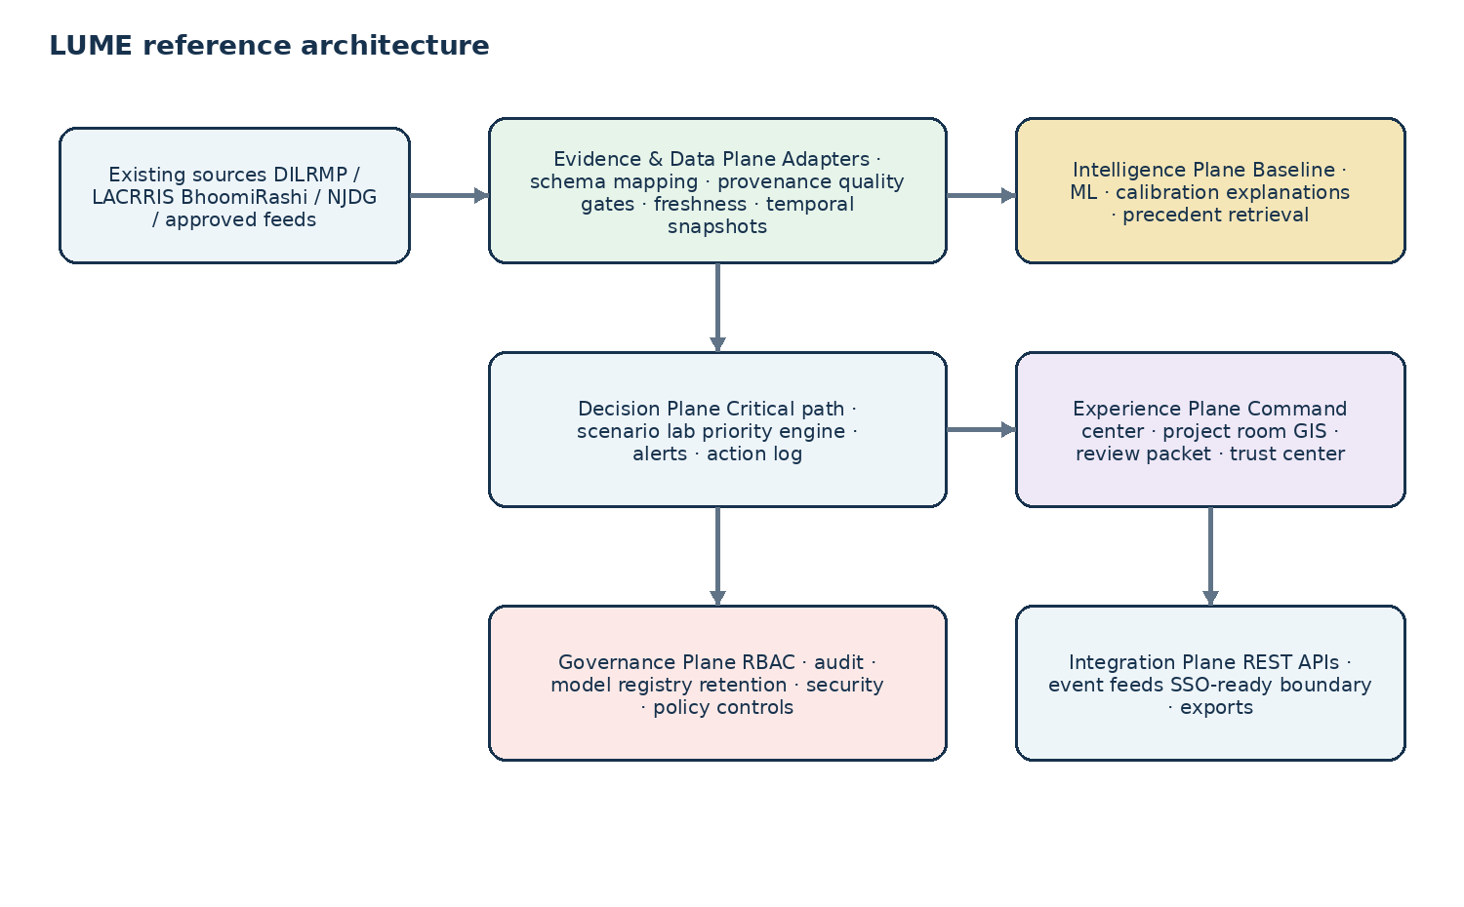

8.1 Pipeline contract
- Ingest only authorized or explicitly permitted source records.
- Validate schema, types, ranges, references and timestamps.
- Normalize terminology into the canonical model.
- Attach provenance, effective time, retrieval time and reliability class.
- Run quality gates before feature generation.
- Generate point-in-time-safe features.
- Score, calibrate and attach coverage/evidence metadata.
- Persist prediction and audit records.

8.2 Evidence Health
State | Data condition | System behavior
GREEN | Recent, complete enough, internally consistent and within supported model coverage. | Normal probability display with confidence and evidence trace.
AMBER | Some missing/stale inputs or partial support. | Constrained confidence, explicit evidence gaps and cautious interpretation.
RED | Unsupported or insufficient evidence. | Baseline or abstention; display what additional evidence is needed.

9. AI / ML Product Contract
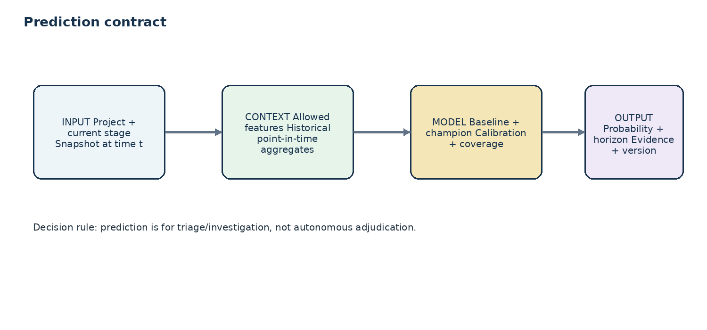

9.1 Prediction definition
Contract element | Final definition
Unit of prediction | One project observed at one supported process stage at time t.
Primary target | Whether the next applicable milestone will miss its stage-specific expected window inside horizon H.
Horizon | Stage/route-specific and explicitly documented.
Prediction timestamp | Latest point at which the model may observe information.
Allowed features | Only information available at or before t, plus point-in-time-safe historical aggregates.
Output | Calibrated probability + horizon + evidence health + coverage + top drivers + model/version metadata.
Fallback | Transparent historical baseline or abstention when support is insufficient.
Decision use | Triage and investigation, not autonomous legal/administrative adjudication.

9.2 Model stack
Layer | Implementation | Purpose
Baseline | Historical stage duration quantiles and calibrated logistic benchmark. | Transparent reference floor.
Champion | Gradient-boosted trees such as LightGBM/XGBoost for supported tabular features. | Capture nonlinear patterns.
Calibration | Isotonic or Platt calibration where validated. | Make probability useful for triage.
Explanation | SHAP/local attribution + evidence mapper. | Translate model signal into inspectable reasons.
Coverage | Training-range and similarity/support checks. | Prevent false confidence.
Monitoring | Temporal performance, calibration, drift and coverage. | Maintain reliability.

9.3 Feature families
Family | Examples
Process | Stage age, elapsed vs expected, event frequency, inactivity gaps, unresolved items.
Approval / clearance | Pending count, age, route-specific dependency state.
Compensation process | Award/payment status, unresolved payment events, authorized valuation-process signals.
Legal / dispute | Authorized case metadata, open dispute state and stage context.
R&R / stakeholder process | Authorized progress/responsiveness indicators, where permitted.
Historical context | District/authority/route stage performance, comparable precedent patterns.
Spatial context | Approved geospatial aggregates such as nearby project density or precedent similarity.
Project context | Department, route, project type and criticality.

9.4 Evaluation protocol
- Temporal holdout evaluation only for final model reporting.
- Feature-level point-in-time audit for leakage prevention.
- Baseline comparison before any champion claim.
- Measure PR-AUC/ROC-AUC, calibration error/Brier score, Precision@K, Recall@K, warning lead time and coverage.
- Version dataset snapshot, feature specification, training period, model, calibration and metrics.
- Promote a champion only when it beats the baseline under predefined holdout criteria and its explanations are reproducible.

10. Explainability, Evidence & Trust
LUME treats explainability as traceability. A useful explanation answers four questions: what does the model believe, why does it believe it, what evidence was observed, and how much support exists for this case?
Layer | What the user sees
Prediction | Probability, stage, horizon, timestamp, coverage, evidence health, model version.
Drivers | Ranked operational reasons in plain language.
Evidence | Source system/type, event/field, effective time, retrieval time, reliability.
Coverage | Training/support status and relevant support warnings.
Action | Associated investigation playbook or priority category.
Audit | Who viewed, ran, acknowledged or changed the decision record.

EVIDENCE CHAIN
Prediction → driver → source event/field → effective time → freshness → feature/model contribution → action context.

11. Critical Path & Dependency Intelligence
A high-risk factor is not always the same thing as the dependency that can block the next milestone. LUME therefore maintains a separate dependency model.
Signal | Interpretation
Stage age | How long the project has remained in its current stage.
Dependency age | How long the blocking condition has remained unresolved.
Downstream reach | Which later milestones rely on resolution of the dependency.
Owner state | Assigned, pending or unassigned where the source permits.
Risk interaction | How the dependency is associated with the next-stage prediction.
Actionability | Whether a documented follow-up exists and can be assigned.

11.1 Critical Path View
The Project Room visually separates “risk factors” from “critical dependencies,” allowing an officer to see which unresolved item is most consequential to the next milestone and why.

12. Precedent Intelligence & Institutional Memory
Every completed acquisition can become a structured case in LUME’s institutional-memory layer. Precedent retrieval is based on analytical comparability, not simple geographic proximity.
Precedent element | Requirement
Similarity | Score plus human-readable reasons.
Process pattern | Shared route/stage/event pattern.
Outcome | Observed resolution or delay outcome.
Intervention | Recorded response/outcome where available.
Evidence quality | Completeness, freshness and reliability context.
Spatial context | Map position and proximity/region context.

12.1 Federated precedent graph
At scale, authorized projects from multiple departments/programs can contribute to a governed precedent layer. Each organization controls what it shares; LUME exposes only permitted fields and preserves source ownership.

13. Intervention Scenario Lab
The Scenario Lab is the signature interaction: an officer can change a supported assumption, observe how the same model responds, inspect the evidence behind the sensitivity, and update the intervention queue.
Step | System behavior
Baseline | Display current probability, evidence health and top drivers.
Scenario | Modify a supported input inside an approved range.
Support check | Validate the scenario remains within supported training/feature ranges.
Re-score | Apply the same model/version contract.
Compare | Show baseline vs scenario probability and absolute delta.
Prioritize | Recompute intervention priority.
Capture | Record scenario assumptions and human decision.

SCIENTIFIC BOUNDARY
A scenario is a modelled sensitivity under stated assumptions. It becomes a causal claim only after a separate evaluation design establishes causality.

13.1 Intervention Priority Index
Prototype formula: IPI = w1·RiskMovement + w2·Urgency + w3·ProjectCriticality + w4·Actionability. Weights are configurable, versioned and visible to administrators. The design is intentionally transparent so users can understand why one follow-up is prioritized above another.

14. GIS, Comparative Analytics & Portfolio Intelligence
Capability | Product behavior
Risk map | Active project markers reflect stage risk and evidence health.
Precedent layer | Toggle comparable completed cases.
Synchronized filters | Stage, department, geography, criticality and risk filters update map and list.
Drill-down | Selecting a project opens its Project Intelligence Room.
Spatial analytics | Approved location aggregates support precedent retrieval and selected features.
Comparative analytics | Stage/district/state/department/route comparisons reveal recurring patterns.

15. LUME Citizen & Stakeholder Transparency — Future Surface
The citizen layer is an expansion of the same data core, not the MVP. Its purpose is to provide authorized, plain-language access to official status and verified milestone changes where disclosure is permitted.
Citizen capability | Design
Official status | Read-only milestone/status view from authorized sources.
Notifications | Verified change events only.
Document access | Only documents intended for the citizen/user under policy.
No speculative risk | Do not expose internal prediction as a legal or compensation claim.
Feedback | Structured citizen-submitted observations may be accepted into a review queue, clearly marked as unverified until validated.

16. Security, Privacy & Responsible AI
- Least-privilege RBAC with role and, where needed, field-level controls.
- Encryption in transit and at rest in production.
- PII minimization and masking where identity is not necessary for the task.
- Source ownership and provenance preserved.
- Model, schema, data and decision records versioned.
- Auditability for prediction, scenario, action and administrative events.
- Human review remains the operational decision boundary.
- Configurable retention and deployment-specific data policies.
- No autonomous legal adjudication, compensation determination, citizen labelling, or government order generation.
RESPONSIBLE-AI CONTRACT
LUME predicts process risk and prioritizes investigation. It does not decide legal rights, determine compensation, label citizens, or issue government orders.

17. Technical Architecture & API Contract

Layer | Recommended implementation | Reason
Frontend | React + TypeScript | Reusable, fast dashboard implementation.
GIS | MapLibre GL JS / Leaflet | Open, flexible spatial experience.
Backend | FastAPI + Python | Strong fit for APIs and ML.
ML | scikit-learn + LightGBM/XGBoost + SHAP | Tabular ML, calibration and explainability.
Database | PostgreSQL + PostGIS | Relational integrity plus spatial queries.
ETL | Python/Pandas + validated adapters | Rapid transformation of provided/authorized data.
Workers | Lightweight background worker; Celery/RQ optional | Alerts and asynchronous tasks.
Auth | RBAC + JWT/OAuth-ready boundary | Production-compatible abstraction.
Deployment | Docker Compose; cloud-ready containers | Reliable local SIH demo and pilot migration path.

17.1 API surface
Endpoint family | Purpose
/projects | Portfolio and project retrieval/filtering
/predictions | Prediction execution/read + metadata
/evidence | Source/evidence trace
/precedents | Comparable case retrieval
/scenarios | Scenario execution/comparison
/actions | Priority queue + decisions
/alerts | Notification subscriptions/events
/audit | Audit/decision events
/models | Model/version registry
/health | Data/model/service health

18. Operational Readiness
Control | Requirement
Health | Data, API, worker and model health indicators.
Observability | Structured logs, latency and error tracking.
Model monitoring | Drift, calibration, coverage and temporal performance.
Data monitoring | Freshness, completeness, nulls, schema changes and source failures.
Versioning | Every prediction references data/feature/model versions.
Rollback | Previous model version remains identifiable and reproducible.
Configuration | Thresholds, weights and policies are versioned.
Offline resilience | Core SIH demonstration works without live external APIs.

19. Business Model & Investment Thesis

19.1 Product-to-business ladder
Phase | Buyer / partner | Offer | Value proof
Pilot | Department / state agency / program / implementation partner | Bounded proof-of-value deployment | Lead time, queue quality, review efficiency and data maturity.
Scale | Department / multiple programs | Annual platform + integration + support | Portfolio decision intelligence and workflow embedding.
Federation | Multiple agencies/programs | Enterprise license + governed analytics/API | Cross-program precedent density and standardized intelligence.
Expansion | Infrastructure organizations | Readiness intelligence modules/APIs | Broader pre-construction dependency visibility.

19.2 Commercial moat
- Validated project-stage-event-outcome history compounds over time.
- Integration adapters reduce future deployment friction.
- Model evaluation history and evidence mappings build institutional trust.
- Workflow embedding creates switching cost through accumulated stage taxonomy, evidence mapping and validated history.
- Precedent retrieval improves as governed case density increases.

19.3 Investor thesis
INVESTOR THESIS
Start with the acquisition bottleneck. Build the intelligence layer. Earn trust through measurable outcomes. Expand from land-acquisition prediction into the broader infrastructure-readiness decision platform.

19.4 Business validation method
LUME should not invent a market-size number. Build the commercial case bottom-up from verified pilot programs, annual software/integration value per program, addressable program count and realistic expansion assumptions after customer discovery. This keeps the investor story ambitious while making its numbers defensible.

19.5 Long-term category
The reusable product primitive is not “land acquisition software.” It is evidence-backed triage for queues of slow-moving, dependency-heavy cases: rank risk, explain the ranking, retrieve precedent, test supported scenarios, and turn the result into accountable action. Land acquisition is the initial high-value wedge.

20. Expansion & Global Transferability
Domain | Why the same architecture transfers
Infrastructure right-of-way | Landowner negotiation, utility coordination and multi-authority sign-off share dependency-heavy process behavior.
Municipal permitting | Projects move through repeatable stages with approval, document and ownership bottlenecks.
Public works approvals | Common process, dependency and escalation signals can use the same Project/Stage/Event model.
Enterprise operations | The same risk-evidence-precedent queue can apply to other regulated, slow-moving workflows with suitable controls.

SCOPE DISCIPLINE
SIH remains focused on land-acquisition intelligence. Global/domain expansion is a company option enabled by the architecture, not a feature expansion required for the SIH prototype.

21. Impact & Measurement Framework
Outcome | Primary KPI | Measurement
Earlier warning | Median warning lead time | Prediction timestamp vs actual milestone miss.
Better triage | Precision@K / Recall@K | Top action queue vs observed risky cases.
Useful probability | Brier score / calibration error | Temporal holdout.
Faster review | Review time per project | Observed user workflow time.
Action conversion | % prioritized cases with follow-up | Decision/action audit log.
Faster resolution | Time from detected bottleneck to resolution | Stage/event history.
Data maturity | Evidence-health coverage | Pipeline metrics.
Institutional learning | % completed cases with validated outcomes | Outcome capture.

21.1 Impact logic
Signal quality → earlier recognition → more selective attention → faster investigation → accountable action → improved outcome record → stronger future intelligence. The causal impact of LUME itself should be evaluated in pilots rather than assumed.

22. SIH Evaluation Target: 10/10 Product Standard
These are internal design targets. They are achieved by evidence in the prototype, not by wording in the document.
Evaluation dimension | 10/10 design standard | Evidence the prototype must show
Problem fit | Directly solves the specific SIH26017 need. | Stage-level delay prediction, drivers, GIS, alerts, recommendations, comparative analytics and learning loop.
Innovation | A distinctive closed decision loop, not generic AI. | Prediction + evidence + precedent + scenario + priority + outcome.
Technical feasibility | End-to-end working system on controlled data. | Live prediction, APIs, DB, UI, GIS and local deployment.
Problem-solving | Turns prediction into action. | Critical dependency and intervention queue visibly update.
Practicality | Complements existing systems and can pilot incrementally. | Connector/API boundary and source-of-truth separation.
Impact | Measurable outcomes with a defined evaluation plan. | Lead time, queue quality and action metrics.
UX | Officer understands result without model training. | Portfolio → project → why → precedent → scenario → action.
Completeness | Closed operational loop. | Data → prediction → decision → outcome.
Sustainability | Trust and learning compound. | Outcome capture + model registry + audit.
Future scope | Clear path without diluting core. | Federated precedent + infrastructure readiness expansion.
Presentation | One decisive story. | Seven-minute demo completed without manual explanation of hidden steps.
Responsible AI | Trust is visible, not asserted. | Evidence chain, support state, human decision boundary.

23. The 7-Minute SIH Demo
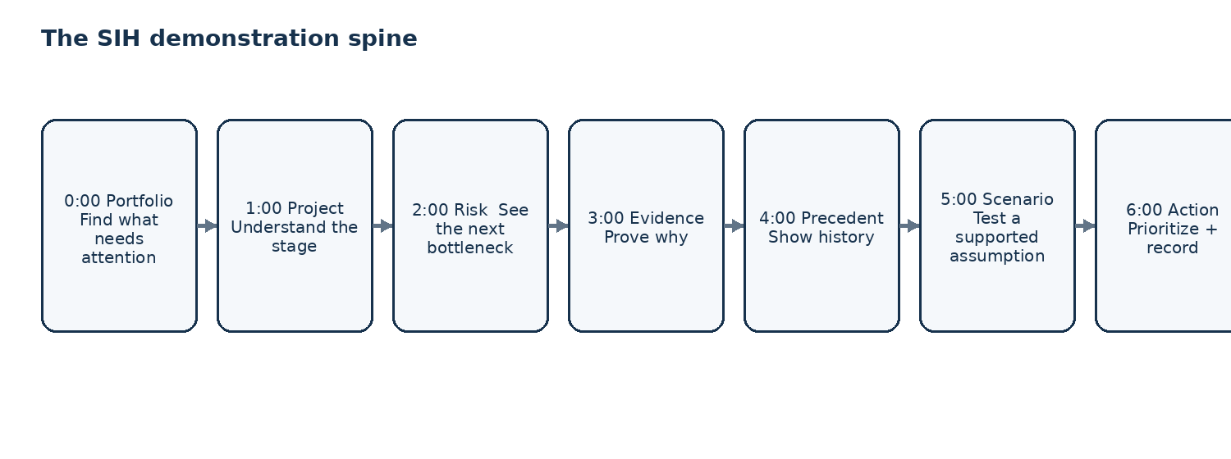
Time | Action | What the judge should understand
0:00–1:00 | Portfolio | We prioritize the operational problem.
1:00–2:00 | Project Room | We understand the actual process state.
2:00–3:00 | Prediction + critical path | We predict the next bottleneck and connect it to dependencies.
3:00–4:00 | Evidence + precedents | We can prove why and show comparable history.
4:00–5:00 | Scenario Lab | We can explore a supported intervention assumption.
5:00–6:00 | Priority + decision log | We move from prediction to accountable action.
6:00–7:00 | Trust Center | The system is governed, versioned and inspectable.

23.1 Opening line
OPEN
“Government already records the acquisition process. LUME makes those records predictive—so the next bottleneck becomes visible while there is still time to act.”

23.2 Closing line
CLOSE
“LUME turns records into foresight, foresight into prioritized action, and completed projects into institutional memory.”

24. Judge-Ready Core Answers

What exactly does LUME predict?
Whether the next applicable milestone for a project at a defined stage is likely to miss its stage-specific expected window within a defined horizon.

Why do we need LUME when government already has portals?
Because LUME is not replacing the source-of-truth portals. It adds a predictive, evidence and decision layer above them.

Why is this innovative?
The innovation is the closed decision loop: stage prediction, traceable evidence, comparable precedent, controlled scenario sensitivity, transparent intervention priority and outcome learning in one workflow.

What if the underlying data is incomplete?
Evidence health and model coverage are visible. The system can constrain confidence or fall back to a baseline rather than create false precision.

How do you prevent data leakage?
Point-in-time feature generation, temporal holdout evaluation, and an explicit prediction timestamp define what the model is allowed to see.

Is the scenario simulator causal?
It is modelled sensitivity under explicit assumptions. A causal claim requires separate evaluation.

What is the moat?
The moat is the permissioned normalized history of project-stage-event-outcome relationships, plus provenance, validated evaluation history and workflow embedding.

Why would government adopt it?
It can be introduced incrementally as an intelligence layer and accessed through APIs without replacing authoritative records.

Can this become a company?
Yes. The initial wedge is land-acquisition intelligence; the architecture can expand into infrastructure-readiness intelligence once outcomes are validated.

What do you build first?
The P0 closed loop: controlled data ingestion, prediction, evidence explanation, critical path, precedents, scenario lab, priority queue, GIS, audit and governance.

25. Product Roadmap & Delivery Plan
Phase | Scope | Exit criterion
SIH prototype | Controlled dataset; P0 decision loop; local deployment. | End-to-end demo + reproducible model evaluation.
Pilot | One department/program; approved connectors; operational feedback. | Measurable lead time, queue quality and trust review.
Multi-district | Multiple portfolios; stable adapters; monitoring. | Reliable multi-program deployment.
Cross-agency | Governed multi-source federation; precedent layer. | Approved cross-program intelligence.
Infrastructure readiness | Adjacent dependencies such as right-of-way and clearances. | Validated extension module with new outcome metrics.

25.1 Six-week SIH engineering plan
Week | Engineering focus | Exit deliverable
1 | Data + ontology | Canonical schema, route-aware stage taxonomy, label definition, temporal/leakage checklist.
2 | ML foundation | Baseline, champion candidate, calibration and evaluation notebook.
3 | Decision UI | Command Center, Project Room, prediction and explanation drawer.
4 | Intelligence | Critical path, precedents, GIS, scenario lab and intervention queue.
5 | Trust + operations | Evidence health, RBAC, audit, alerts, model registry, review packet.
6 | Hardening | Offline mode, performance, QA, demonstration script and documentation.

26. Definition of Done
Area | Acceptance criterion
Data | Every demo prediction is traceable to a point-in-time feature state and source provenance.
Process taxonomy | Supported route stages are mapped explicitly; no universal sequence is assumed.
Model | Baseline and champion metrics are reproducible on temporal holdout.
Prediction | Every output states stage, horizon, probability, coverage, evidence health and version.
Explainability | Displayed drivers trace to evidence records.
Critical path | At least one dependency can be traced to downstream effect and actionability.
Precedent | At least three meaningful comparable cases are retrievable in the seeded demo.
Scenario | A supported scenario changes the model output and displays assumptions/support state.
Priority | Action queue recomputes using transparent, versioned logic.
GIS | Map and portfolio filters remain synchronized.
Alerts | At least one threshold/change alert is demonstrated.
Security | Unauthorized role actions fail.
Audit | Prediction, scenario and action events are logged.
Offline | Core demonstration works without live external APIs.
Presentation | Core narrative completes within seven minutes.

27. Future Innovation Portfolio
Future capability | Value
Temporal graph models | Learn relationships among events, dependencies and stage transitions over time.
Authorized document understanding | Extract structured event signals from permitted notices/orders.
Federated analytics | Learn cross-program patterns without unnecessarily centralizing sensitive source data.
Causal intervention evaluation | Measure actual effect of recommended interventions in suitable pilot designs.
Multilingual experience | Make government decision support accessible across language contexts.
Event-driven architecture | Refresh predictions as material evidence changes rather than on fixed schedules only.
Policy simulation | Explore how process-rule changes might alter bottleneck patterns at portfolio level.
Citizen transparency | Provide verified official status without exposing internal predictive judgments.

28. Adoption, Procurement & Operating Model

28.1 Adoption strategy
- Start with one well-defined program and a bounded set of stages.
- Prove measurable value before expanding data sources.
- Integrate through adapters/APIs rather than forcing a system replacement.
- Train users through the Project Room journey, not through ML terminology.
- Establish a model/data governance owner before wider rollout.

28.2 Deployment patterns
Pattern | Use
Local / air-gapped style deployment | Sensitive pilot environments and SIH demonstration.
Government-controlled cloud / data center | Production deployment where permitted by policy.
Hybrid | LUME services separated from source systems with controlled API access.

28.3 Support model
Production operations should include application support, data-source monitoring, model-performance review, security review, connector maintenance and recurring user feedback. This is part of the product, not an afterthought.

29. Prize Money / Seed Funding Utilization

29.1 Recommended allocation framework
Use | Indicative share | Purpose
Prototype & product engineering | 35% | Core product hardening, UI/UX, reliability and integration work.
Data / ML validation | 25% | Data preparation, evaluation, model experiments and validation support.
Security & deployment | 15% | Infrastructure, security assessment, deployment tooling.
Pilot & user research | 15% | Field validation, user studies and operational testing.
Documentation / compliance / IP | 5% | Documentation, governance and IP hygiene.
Contingency | 5% | Unexpected technical or pilot requirements.

Percentages are planning guidance, not committed spending. Actual allocation should follow the evidence gained from the SIH prototype and pilot conversations.

30. Evidence & Research Register
The PRD is grounded in the uploaded LUME concept and the four prior PRDs, with current public-source verification used for the ecosystem statements below.
SIH26017 problem statement — SIH 2026 problem explorer. Source Official problem statement context, required capabilities and dataset note.
SIH 2026 problem list — SIH 2026 problem explorer. Source Confirms SIH26017 title and technology domains.
DILRMP MIS — Department of Land Resources. Source Public dashboard for land-record modernization indicators.
DILRMP map/ULPIN status — Department of Land Resources. Source Public state/UT map, cadastral and ULPIN status indicators.
BhoomiRashi — Ministry of Road Transport & Highways. Source National Highway land-acquisition portal/workflow.
LARR / DoLR — Department of Land Resources. Source Land acquisition / compensation / rehabilitation information context.
NJDG — eCourts / Supreme Court eCommittee. Source Judicial data and analytics context.
LARR implementation and effectiveness — PRS Legislative Research, 18 Dec 2025. Source Current implementation/community-process context.
Current DILRMP public dashboard — Department of Land Resources. Source Current public evidence of heterogeneous land-information maturity.

31. Final Product Scorecard & North Star
Dimension | Design target | Proof standard
Problem fit | 10/10 | Every P0 feature maps to SIH26017 and the core user decision.
Innovation | 10/10 | Closed prediction-to-action-to-learning loop is demonstrable.
Technical depth | 10/10 | Temporal ML, calibration, coverage, evidence mapping and model registry are real.
Working prototype | 10/10 | All P0 services run end-to-end on controlled data.
Practicality | 10/10 | Existing systems stay authoritative; LUME integrates above them.
Impact | 10/10 | Measurable lead-time, triage and action KPIs defined.
UX | 10/10 | Officer path is understandable without ML training.
Completeness | 10/10 | Data → intelligence → decision → outcome is closed.
Sustainability | 10/10 | Validated outcomes improve future intelligence and operating value.
Future scope | 10/10 | Clear expansion without diluting SIH focus.
Presentation | 10/10 | Seven-minute proof of the complete product contract.
Business | 10/10 | Pilot → scale → federation → infrastructure-readiness path.
Trust | 10/10 | Evidence, coverage, provenance, audit and human control are visible.

31.1 The LUME North Star
LUME
Predict the next bottleneck. Prove why. Show the precedent. Test the assumption. Prioritize the action. Learn from the outcome.

LUME is complete when one judge can select a project and, through one continuous interaction, see where the project is, what stage is most at risk, why the system believes that, which historical cases resemble it, how the model responds to a supported scenario, and what should be investigated first.
The dashboard is the interface. The canonical data model is the foundation. The evidence chain is the trust mechanism. The precedent layer is the institutional memory. The intervention loop is the operational value. The validated history is the moat.
FINAL POSITION
LUME is the predictive intelligence layer for land acquisition—turning existing records into foresight, foresight into prioritized action, and completed projects into institutional memory.

